


9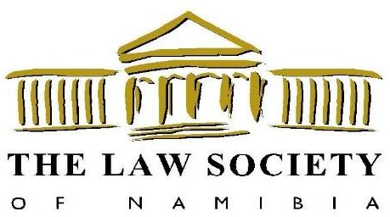

ENTRY FORM
NAME OF TEAM:
MAIN CONTACT: COMPANY/FIRM:
(IF ENTERING AS CORPORATE TEAM)
TELEPHONE: E-MAIL:

TEAM MEMBERS: FIRM NAME:

(Signature)

Send your form and payment to Don-Vito at accounts1@lawsocietynamibia.org
or hand deliver at our offices at Law Society of Namibia, 333 Independence Avenue, First Floor, Namlex Chambers, Windhoek

Terms &Conditions
The Law Society of Namibia’s (LSN) Fun Day will take place on 19 September 2026. Below are the terms and conditions for any member of the Lae Society wishing to participate:

Application
  - All participants must complete and submit the official application form and the proof of payment by the specified deadline.
  - Incomplete applications will not be considered.

Eligibility
Participation in the Fun Day is open to members of the LSN (whether practicing or not) and their staff only.

Participation
3.1. Participants are required to adhere to all event rules and guidelines provided by the LSN.
3.2 The LSN reserves the right to refuse participation to any individual who does not comply with these terms and conditions.

Code of Conduct
  - Participants are expected to conduct themselves in a professional and sportsmanlike manner at all times.
  - Any form of harassment, discrimination, or inappropriate behavior will not be tolerated and may result in immediate expulsion from the event.

Health and Safety
  - Participants acknowledge that volleyball is a physically demanding sport and accept all risks associated with participation.
  - Participants are responsible for ensuring they are physically fit to take part in the event.
  - The LSN will not be liable for any injuries, accidents, damages, or thefts that occur during the event.

Amendments and Cancellation
  - The LSN reserves the right to amend these terms and conditions at any time. Participants will be notified of any changes.
  - The LSN reserves the right to cancel or postpone the event due to unforeseen circumstances. In such cases, participants will be informed as soon as possible.

Photography and Media
By participating in the event, participants consent to being photographed and recorded. These images and recordings may be used for promotional purposes by the LSN.

Payments
The entry fee is N$ 750 per team of ten. Payment can be made by bank transfer (details available below) NB: Bank transfer must be made using the reference Volleyball + Team Name. Confirmation of team entry will only be sent once the entry fee has been received. The last day for entries is 12th of September 2026 and late applications received after the closing date will be N$ 1000.
Bank Details
Account Name: Law Society of Namibia, Account Number: 8000440946, Account Type: Current Account
Branch: Windhoek, Branch Code: 481972, Swift Code: BWLINANX
- Teaming Up
Legal practitioners can combine with others to form a team of ten.

- Proof of employment may be required from the HR if necessary.

Should you require any further information, do not hesitate to contact Don Vito Booys at +264 (61) 230 263 or e-mail at accounts1@lawsocietynamibia.org.

By submitting the application form, participants acknowledge that they have read, understood, and agree to these terms and conditions.

We look forward to your support in participating in this very first Law Society Fun Day!

